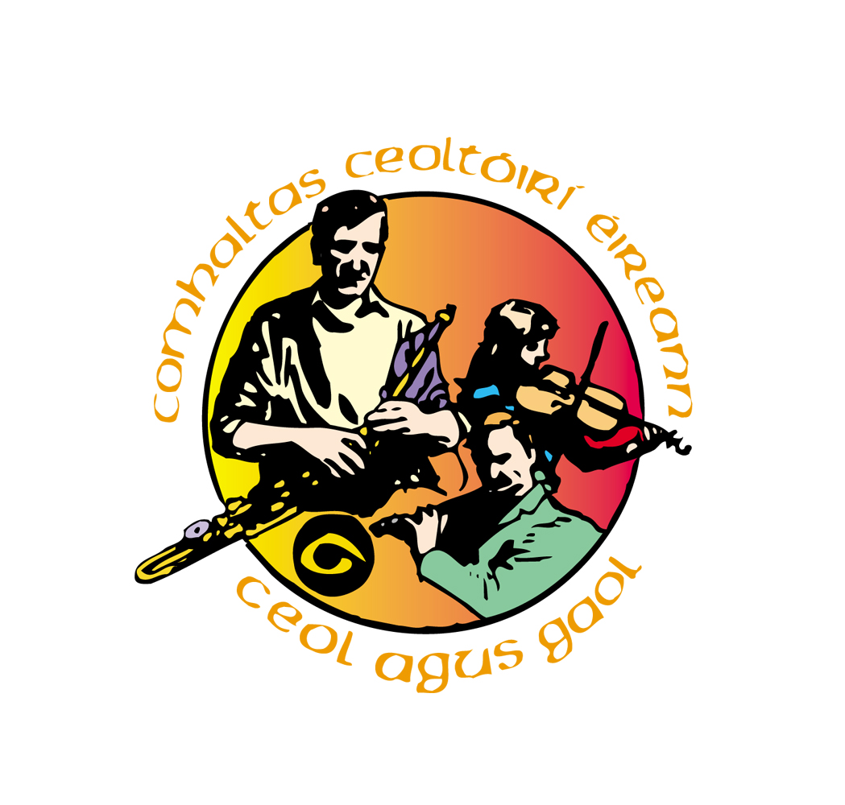
Antrim County Fleadh

Cushendall 13th – 20 ^{th} May

Programme

Sunday 13th Fleadh Concert Rehearsal Parish Centre 4.30pm – 6.30pm

Music Session Glens Hotel 8.00pm Adm Free

Tuesday 15th Set Dancing Workshop Glens Hotel 8.30pm Adm ??

Wednesday 16th Children’s Ceili Parish Centre 7.00pm Adm £1

Thursday 17th Music Session Central Bar 9.00pm Adm free

Singing Night Johnnie Joes 8.30pm Adm free

Friday 18th Fleadh Concert Parish Centre 8. 30pm Adm £4

Junior Traditional Group (musicians drawn from around County Antrim) Antrim & Derry Fiddlers & The Glens Senior Traditional Concert Group.

Saturday 19th Fleadh Competitions St. Mary’s P.S. All day Adm £3

Village ‘G’ Day - All the local business’& community use the Irish language in some small way to help promote and foster the use of Irish.

Historical trail - guided tour around the village with commentary in Irish

Meet in boat Club car park at 3.00pm

Ceili at the Corner - Open air Music & Dancing 8.30pm

Bridge street will be closed to traffic from 8.30 – 10.00pm

Diversions through car park

Sunday 20th Group competitions - Parish centre 12. 30pm Adm £3

Guided Walk 11.00am Meet at boat Club car park Adm free

(1 hour walk walking on quiet roads and paths)

Open Air Concert & BBQ 4.00 – 6.00pm Adm free

(A display of music & dance from around County Antrim)

Cottage Wood Park in Cushendall village


Many impromptu sessions taking place throughout the week.

